# Scavenger Hunt: Careers in Game Design

In this lesson students learn about video game studios and research a studio of their choice. Students then develop a one-page web presentation to share their findings and reflect on types of roles within game studios.

## Objective

Students will be able to:

* Describe a specific role or career in the video game industry
* Explain the job requirements of a chosen career
* Explain the education requirements or skills required to obtain a chosen career

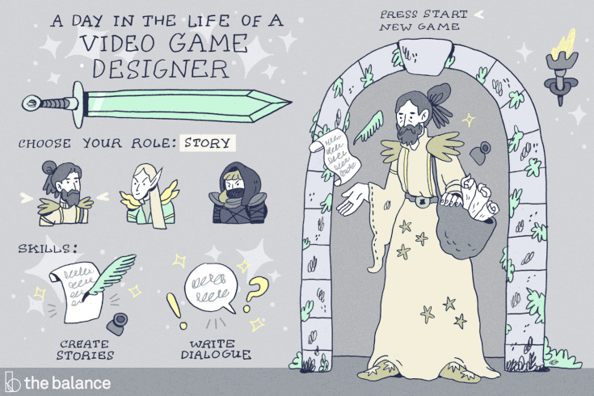

## Overview

For this activity, you will go on a career scavenger hunt. By the end of this activity, you will have had an opportunity to explore the types of careers that exist within the game development industry. You may also be surprised to find how important some non-technical careers are for the industry!

## Objective

Once you have finished all of the following steps, continue onto the next activity to answer the scavenger hunt questions.

**How to Search for Career Info**

1. Open a separate browser tab.
2. Enter the following URL into the new address bar: <https://www.thebalancecareers.com/video-game-jobs-525965>
3. Browse through the career titles, underneath the **Table of Contents** section, located on the left-hand side of the screen.
4. Click on one of the careers (ie. Writers)
5. Once the website brings you to the Writers’ paragraph, click the hyperlink inside that paragraph. This will take you to a page that has all of the career related information for Writers in the game industry.

Consider Your Response to These Questions

1. Read through at least 3 different job types. Which one appealed to you and why?
2. Why do you think there needs to be so many different job types in order to develop a game? How do the different roles relate to one another?
3. Thinking of a game design role that might interest you, what are the educational requirements needed in order to achieve that career?

Now that you’ve had the opportunity to explore a few careers in the video game industry and game design, answer the following questions.

1. What do you find exciting about the field of game design or video game production in general?
2. What skills or characteristics do you feel are important to have for a career in the video game industry?
3. What questions do you still have about careers in video game production or game design?